Doc No: BCIM/HYD/MS/ LH10/03
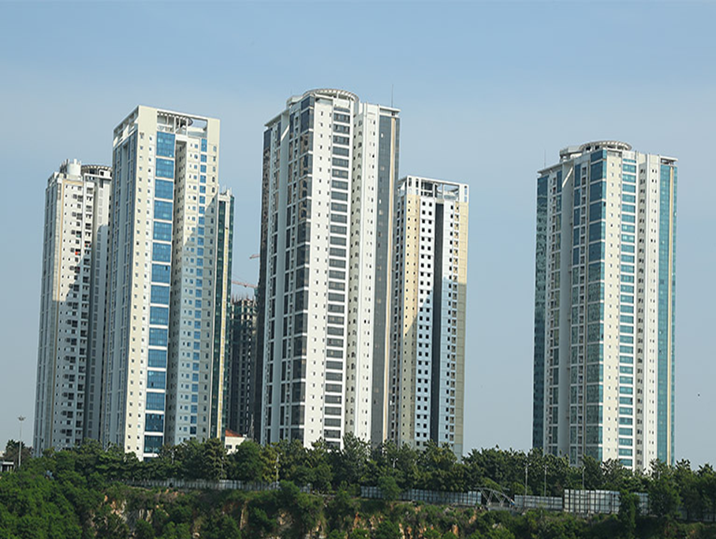
Project Name |  | LANCO HILLS RESIDENTIAL PROJECT- LH 10 ,HYDERABAD
Client |  | LANCO HILLS TECHNOLOGY PARK PRIVATE LIMITED
PMC |  | SAVILLS PROPERTY SERVICES (INDIA) PRIVATE LIMITED
Main Contractor |  | BCIM ENGINEERING PVT LIMITED
REVISION HISTORY
REV.NO | DATE |  | DETAILS OF REVISION
R0 | 13.05.2026 |  | Initial Issue for review and approval
PREPARED BY  BCIM |  |  | REVIEWED BY  BCIM | REVIEWED & APPROVED BY  PMC/Client

- Objective

The purpose of this procedure is to define how floor screed concrete shall be carried out under controlled condition.
- Scope
This method statement covers the detailed procedure to be followed for screed concrete works and read in conjunction with contract specification/Boq wherever applicable.
- References
- Project Specification/BOQ for Concrete Floor Finish
- Contract Drawings

- Tools & Tackles
- Air Blower
- Wire Brush
- Showels
- Metal Float
- Straight edge
- Power Trowel
- Procedure
  - All the related documents such as method statement & M15 grade screed concrete mix design must be approved prior to commencement of work.
  - Free water shall be removed from the sub floor.
  - Screed concrete shall be laid with approved slopes and thickness
  - Check that the Mechanical and Electrical services / ducts under screed has to be ensure to complete and protected as per the drawing/specification.
6.Workmanship
- Level Pads shall be installed at proper intervals as per approved slopes
- The surface of the sub-floor shall be thoroughly cleaned and prepared to ensure a good bonding with screed concrete.
- The screed concrete shall be laid and thoroughly compacted in the bays not exceeding 4.0m wide or otherwise as per the approved shop drawings, layout shall be as per approved shop drawings.

- After completion of casting, enough number of workers must be available for the finishing works, cleaning and protection
- Floor shall be finished to a hard, dense surface free from imperfections
- Broom finish shall be carried out with suitable PVC wire brush before hardening the screed surface in drive ways and parking areas.
7. Curing
- As soon as the screed concrete set it shall be start curing for minimum 3 days
8.Groove Cutting in Joints
- Groove cutting if required shall be done in panel size 4m*4m as specified in BOQ.

ATTACHMENT

- Check list for IPS Screed

